IDE_硬盘读写实验

实验目的
- 了解在UP-CUP S2440平台上实现IDE_硬盘Linux驱动程序的基本原理
- 了解Linux驱动开发的基本过程

实验内容
- 以一个简单块设备驱动程序为原型，剖析其基本结构。进行部分改写之后并编译实现其相应功能

实验环境
- 硬件：UP-CUP2440型嵌入式实验平台，PC机Pentium 500以上, 硬盘40G以上,内存大于256M
- 软件：Vmware Workstation +Fedora Core 8 + MiniCom/Xshell + ARM-LINUX交叉编译开发环境

实验步骤
- 实验目录：/UP-CUP2440/SRC/kernel/linux-2.6.24.4-2440/
- 在内核中添加IDE设备模块驱动

1、进入宿主机中UP-UP2440-II型光盘内核目录：
[root@localhost ~]# cd /UP-CUP2440/SRC/kernel/linux-2.6.24.4-2440/

2、运行 make menuconfig命令配置内核对LED模块的相关支持
选择Device Drivers --->选项，如图
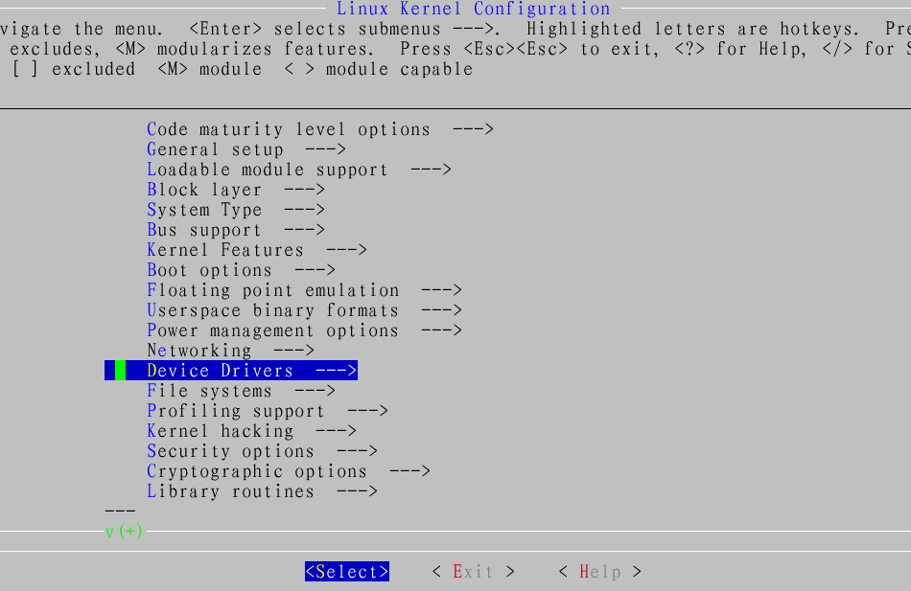
进入ATA/ATAPI/MFM/RLL Support ---> 菜单
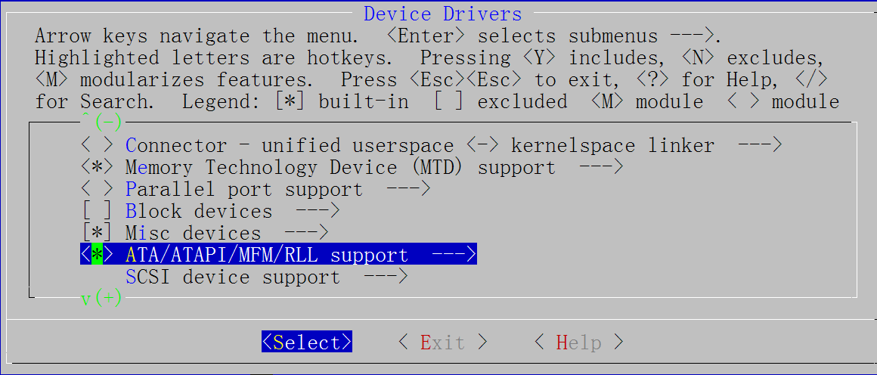

选择<*> IDE Support for arm S3C2440 add by gxj，如图：
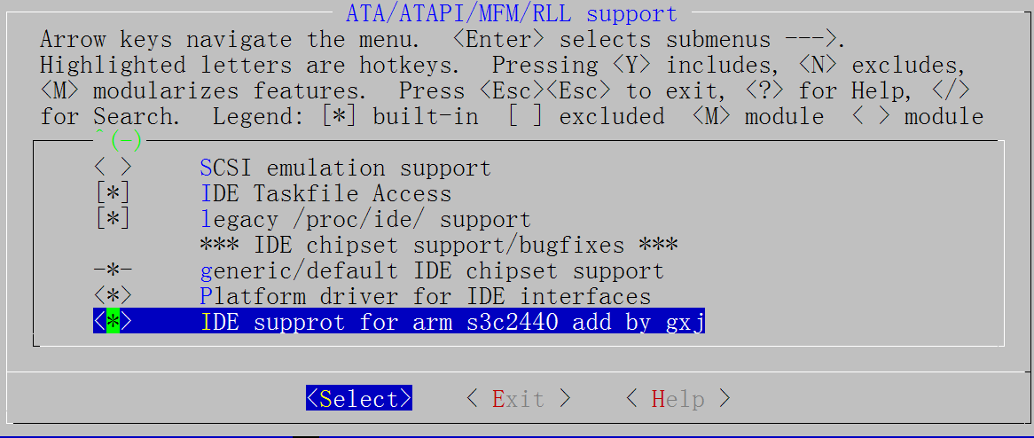
退出保存配置：
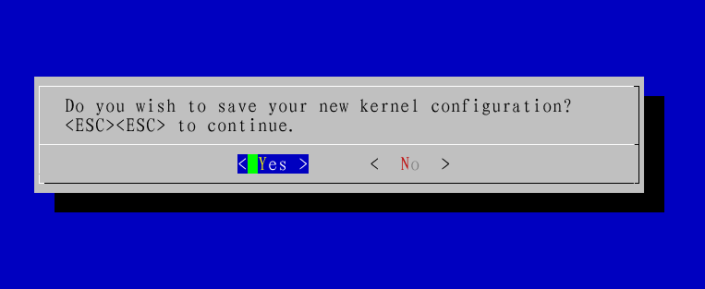
3、重新编译内核,运行make命令
[root@localhost linux-2.6.24.4]# make
scripts/kconfig/conf -s arch/arm/Kconfig
CHK include/linux/version.h
SYMLINK include/asm-arm/arch -> include/asm-arm/arch-s3c
make[1]: `include/asm-arm/mach-types.h' is up to date.
CHK include/linux/utsrelease.h
CHK include/linux/compile.h
备注：以上在内核中添加对IDE设备的支持的步骤，在UP-CUP2440设备出厂自带内核中已经默认添加进入了，用户可以省略以上步骤。以上步骤在于重现系统的构造。
- IDE应用测试
1、未插入硬盘时,UP-CUP2440中关于IDE的启动信息如下显示：
Uniform Multi-Platform E-IDE driver Revision: 7.00alpha2
ide: Assuming 50MHz system bus speed for PIO modes; override with

idebus=xx
oldval_bwscon:0x22111912newval_bwscon:0x22111952iomap:0xc4810020tmp is

0x00
tmp22 is 0x01
iomap:0xc4812010register the ide hw ok!!
oldval_bwscon:0x22111952newval_bwscon:0x22111952iomap:0xc4814020tmp is

0x00
tmp22 is 0x01
iomap:0xc4816010register the ide hw ok!!
2、将硬盘插入实验板的插槽“ATA-44 HDD”插槽后, UP-CUP2440中关于IDE的启动信息如下显示：
Uniform Multi-Platform E-IDE driver Revision: 7.00alpha2
ide: Assuming 50MHz system bus speed for PIO modes; override with

idebus=xx
oldval_bwscon:0x22111912newval_bwscon:0x22111952iomap:0xc4810020tmp is

0x00
tmp22 is 0x01
iomap:0xc4812010register the ide hw ok!!
oldval_bwscon:0x22111952newval_bwscon:0x22111952iomap:0xc4814020tmp is

0x01
tmp22 is 0x01
iomap:0xc4816010register the ide hw ok!!
hda: HTS541040G9AT00, ATA DISK drive
hdc: HTS541040G9AT00, ATA DISK drive
ide0 at 0xc4810020-0xc4810027,0xc481201c on irq 50
ide1 at 0xc4814020-0xc4814027,0xc481601c on irq 50 (shared with ide0)
hda: max request size: 128KiB
hda: 78140160 sectors (40007 MB) w/7539KiB Cache, CHS=65535/16/63
hda: cache flushes supported
hda: hda1 hda2 hda3 < hda5 >
hdc: max request size: 128KiB
hdc: 78140160 sectors (40007 MB) w/7539KiB Cache, CHS=65535/16/63
hdc: cache flushes supported
hdc: hdc1 hdc2 hdc3 < hdc5 >
3、查看硬盘分区
up-tech:~ # ls /dev/hd
hda hda1 hda2 hda3 hda5
4、挂载硬盘。
up-tech:~ # fdisk –l
Disk /dev/hda: 40.0 GB, 40007761920 bytes
240 heads, 63 sectors/track, 5168 cylinders
Units = cylinders of 15120 * 512 = 7741440 bytes

Device Boot Start End Blocks Id System
/dev/hda1 * 1 1355 10243768+ 7 HPFS/NTFS
/dev/hda2 1356 3262 14416920 c Win95 FAT32 (LBA)
/dev/hda3 3263 5168 14409360 f Win95 Ext'd (LBA)
/dev/hda5 3263 5168 14409328+ 7 HPFS/NTFS
[root@UP_2440 ~]# mount -t vfat /dev/hda2 /mnt/udisk/
注：只能挂载FAT32格式
5、测试硬盘
up-tech:~ # cd /mnt/udisk/
up-tech:/mnt/udisk # ls
??2007 ????? Recycled img-2410linux
up-tech:/mnt/udisk # mkdir uptech
??2007 ????? Recycled img-2410linux uptech

